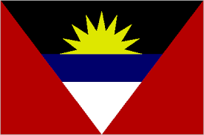

**ANTIGUA & BARBUDA CITIZENSHIP BY INVESTMENT.**

Antigua & Barbuda is an island sovereign state in the West Indies in the Americas, lying between the Caribbean Sea and the Atlantic Ocean.

An Antiguan passport allows the holder visa-free access to a total of **160 countries**, including all countries within the EU Schengen area, the U.K. (6 months within any one-year period), Russia, Central America, South-Africa , the UAE, etc. Other benefits include:

* Free tuition in European universities or at subsidized rates in the UK for you and your dependents.
* Access to medical benefits including free healthcare.
* Possibility to transfer citizenship to children and parents and future generation.
* Tax Free benefits.
* Duty free trading in the Caribbean.

# Citizenship Program & Benefits

The Citizenship by Investment Program (CIP) was established following parliamentary assent to the Antigua and Barbuda Citizenship by Investment Regulations of 2014.The Regulations regarding Citizenship by Investment in Antigua and Barbuda are part of Section 6 of the Citizenship by Investment Act of 2014. This act allows the government of Antigua and Barbuda to grant citizenship to persons who qualify under the criteria set by parliamentary decision.

Citizenship is granted to qualified applicants within 4 to 5 months with no residency requirements. Once the applicant is granted citizenship, he/she becomes a citizen for life.

# FAST FACTS

* **Capital:** St John’s
* **Official Language**: English
* **Currency:** Eastern Caribbean Dollar
* **Population:** 102,000
* **Time Zone:** UTC -4
* **Calling Code:** +1-268

# Requirements

To qualify for citizenship, applicants need to undergo a strict due diligence process, in addition to making a contribution via one of the two following channels:

• Non-refundable contribution to the National Development Fund (NDF)

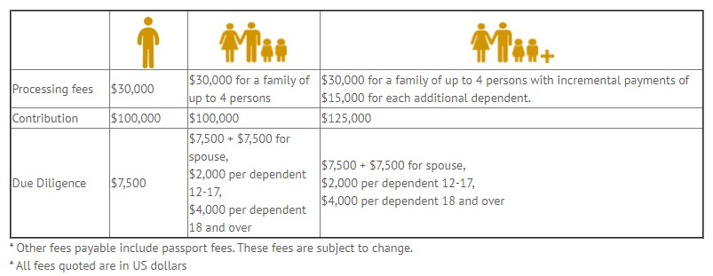

• Purchase of real estate in a government approved project AND payment of applicable government fees

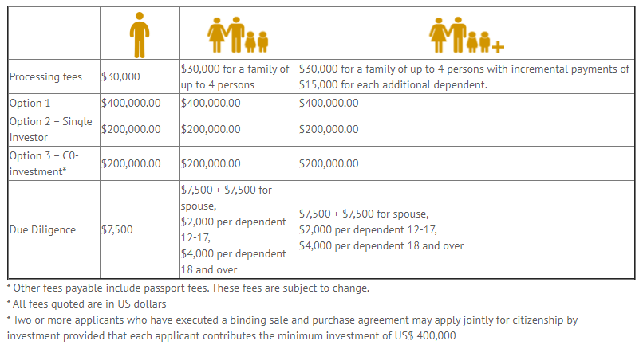

In addition to these fees, The Antigua & Barbuda Citizenship by Investment Programme also include:

* Application Fees.
* Passport Fees.
* Certificate of Naturalization fees.
* Advisory/Legal fees.

# DEPENDENTS.

Family applications will be considered to include the following family members;

* A spouse of the main applicant
* A child of the main applicant or his or her spouse who is less than 18 years of age
* A child of the main applicant or of his/her spouse who is at least 18 years and less than 28 years of age and who is in full time attendance at a recognized institution of higher learning and fully supported by the main applicant
* A child of the main applicant or of the spouse of the main applicant who is at least 18 years of age, who is physically or mentally challenged, and who is living with and fully supported by the main applicant
* Parents or grandparents of the main applicant or of his/her spouse above the age of 58 years living with and fully supported by the main applicant.

For the purposes of the Antigua and Barbuda Citizenship by Investment Program ‘child’ means a biological or legally adopted child of the main applicant, or of the spouse of the main applicant.